Climate Monitoring Brief: Dry Tortugas National Park

Atlantic Oceanographic & Meteorological Laboratory National Oceanic Atmospheric Administration

N. Besemer, G. Kolodziej, M. Jankulak, A. Palacio, I. Enochs - July 2021

### About this summary brief

The NOAA Atlantic Oceanographic and Meteorolgical Laboratory (AOML) conducts the long-term [National Coral Reef Monitoring Program (NCRMP)](https://www.coris.noaa.gov/monitoring/welcome.html) to track the status and trends of coral reef ecosystems of the U.S. Atlantic and Caribbean coral reef jurisdictions. This FY21 summary brief provides an overview of the most recent survey efforts.

### Sampling effort

* The most recent NCRMP Atlantic climate monitoring took place at Dry Tortugas National Park from June 24th to June 29th 2021
* Four different sites were monitored by collecting and deploying instruments that monitor temperature, current, pH, light, bioerosion and calcification
* At the Bird Key Reef site, landscape mosaics (n=6) and carbonate budget surveys (n=6) were completed to monitor changes in benthic cover and carbonate production

### Spatial sample design

Survey site locations were selected to represent temporal‐resolution monitoring with moored instruments at fixed time‐series. These sites were placed on depth gradient to assess how vertical structure affects reef status and trends. Pulaski Shoal (1m), White Shoal (5m), Bird Key Reef (15m), and Black Coral Rock (25m) are the selected study sites.

### Sampling methods

Subsurface Temperature Recorder (STR)s were placed at all 4 sites and collected temperature measurements at 5-minute intervals for 3 years. At Bird Key Reef additional instruments were deployed for a 72-hour diurnal suite. SeaFET pH logger, Tiltmeter and EcoPAR collected measurements at 5-minute intervals. Subsurface Automatic Samplers (SAS) collected discrete water samples at three-hour intervals (n=24).

### Overview of data collected

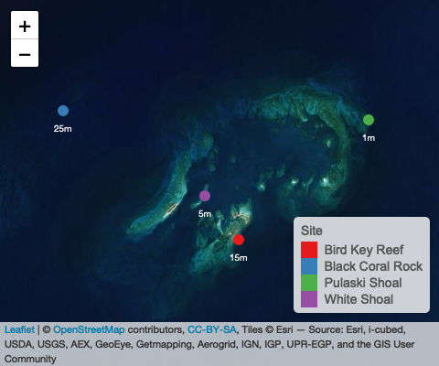

Map of study sites in Dry Tortugas National Park area

#### Temperature Data

Plot option 1:

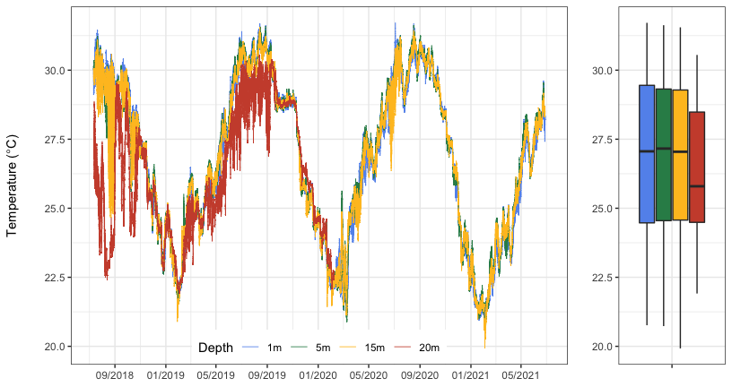

**Figure 1:** Temperature data collected for 3 years at four sites in the Dry Tortugas at 1 m (Pulaski Shoal Lighthouse), 5m (White Shoal), 15m (Bird Key Reef) and 25 m (Black Coral Rock).The 1m, 5m, and 15m collected data for the full deployment. The 25m STR stopped collecting on Febuary 7th 2020.

#### Diurnal Suite Deployment

option 1

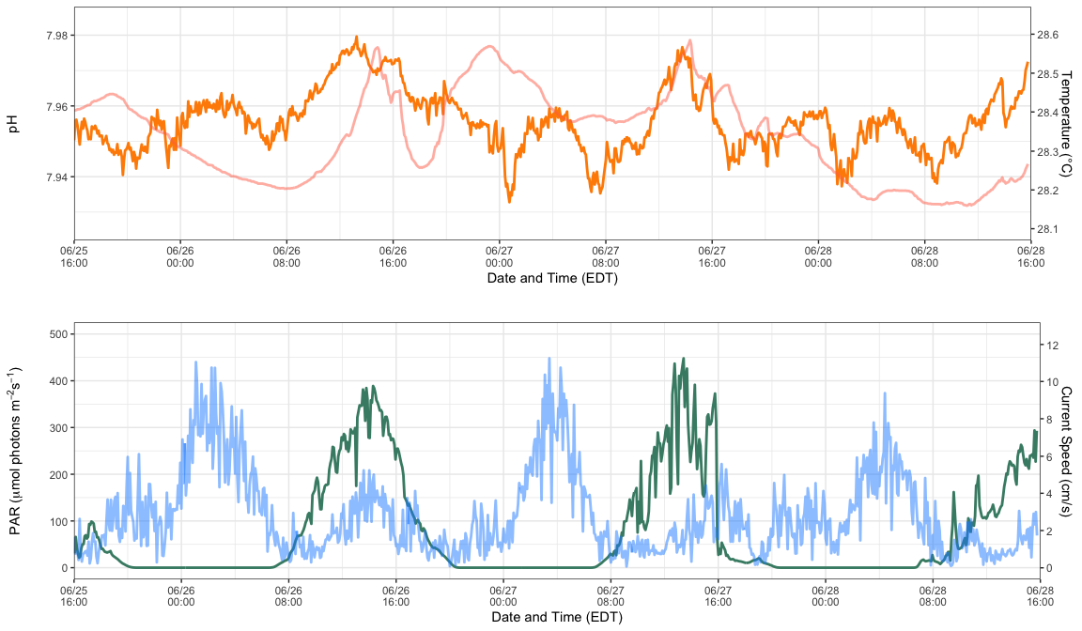

**Figure 2:** Summary plots of pH paired with Temperature, and current speed paired with PAR collected from instrument deployment at Bird Key Reef site around 15 meters from June 25th to June 28th. Instruments measured parameters every 5 minutes.

option 2:

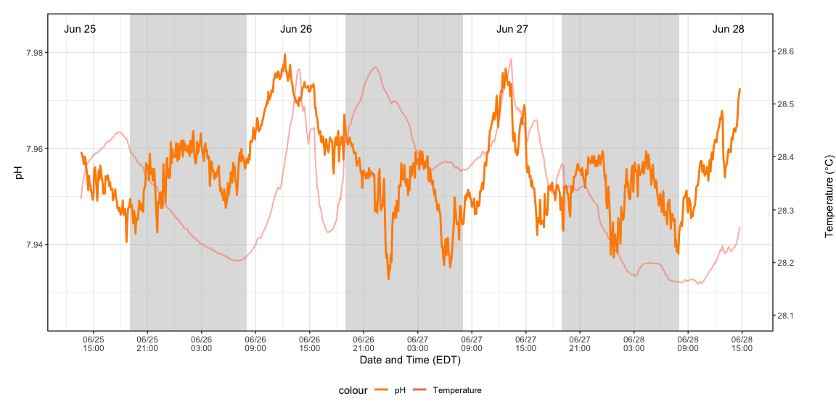

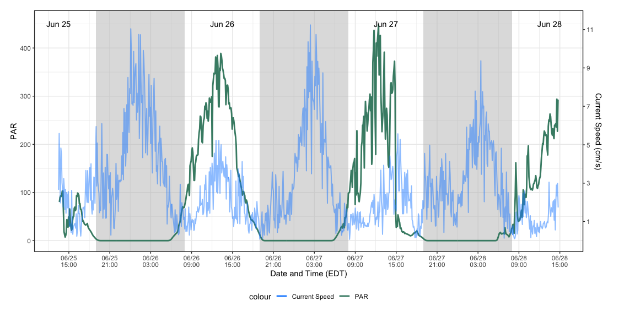

**Figure 2:** Summary plots of pH paired with Temperature, and current speed paired with PAR collected from instrument deployment at Bird Key Reef site around 15 meters from June 25th to June 28th. Instruments measured parameters every 5 minutes.

### Summary table

### By year and region

|  |  |  |  |
| --- | --- | --- | --- |
| Data | Number of observations | Days running | Notes |
| Temperature (STRs) | 1.1 million | 700 days | 4 depths |
| pH | number | number | number |
| Light | number | number | number |
| Current | number | number | number |

### About the monitoring program

AOML’s climate monitoring is a key part of the National Coral Reef Monitoring Program of NOAA’s Coral Reef Conservation Program (CRCP), providing integrated, consistent, and comparable data across U.S. Managed coral reef ecosystems. CRCP monitoring efforts aim to:

* Document the status of reef species of ecological and economic importance.
* Track and assess changes in reef communities in response to environmental stressors or human activities.
* Evaluate the effectiveness of specific management strategies and identify actions for future and adaptive responses.

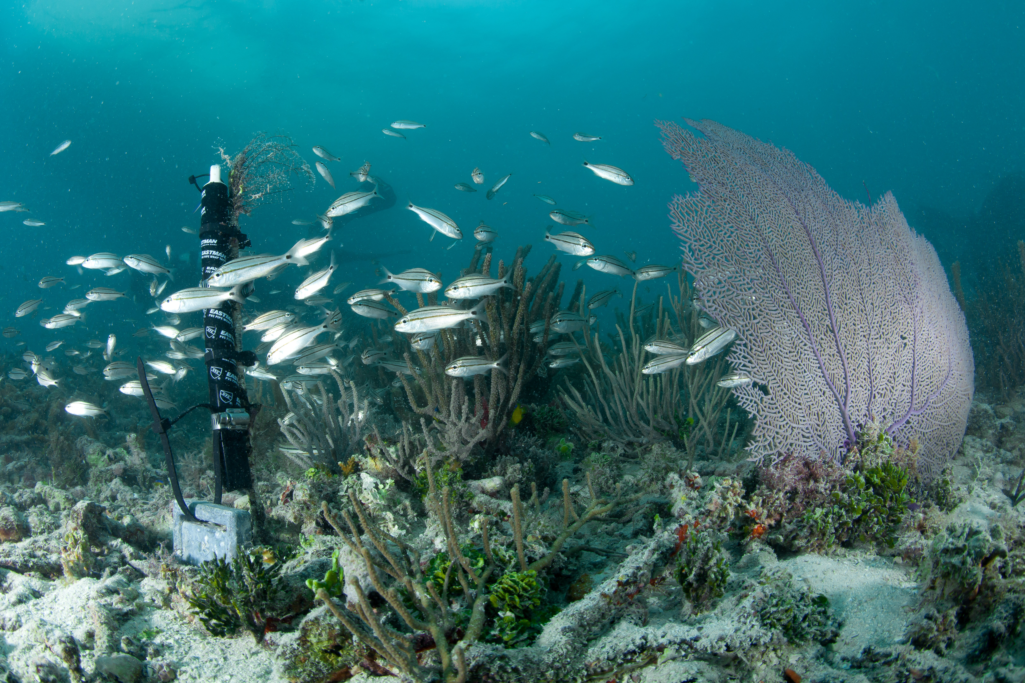

New STR depolyed at White Shoal in Dry Tortugas National Park

### For more information

Coral Reef Conservation Program: <http://coralreef.noaa.gov>

NCRMP climate page: <https://www.coris.noaa.gov/monitoring/climate.html>

NOAA Atlantic Oceanographic and Meteorological Laboratory: <http://www.aoml.noaa.gov/>

Atlantic Climate team lead: [nicole.besemer@noaa.gov](mailto:nicole.besemer@noaa.gov)

NCRMP Coordinator: [erica.towle@noaa.gov](mailto:erica.towle@noaa.gov)